Tommy Wu

IoT Solution Architect Microsoft

Building Your Own Device for

AI Care with Azure AI & IoT Services

Project AI Care 技術白皮書

AI Box Hands-on Lab Guide

目錄

1 Background and Challenge 2

2 Solution Overview 2

3 AI CARE Device Hardware Architecture 2

4 AI CARE System Architecture 4

5 Hands-On Guide Tutorial 6

5.1 M5StackCore 6

5.2 ESP32 CAM 7

5.3 Battery 8

5.4 Mask Training with Azure Custom Vision 9

5.5 Edge Computing with Azure IoT Edge 10

5.6 Power BI Dashboard 12

5.7 IoT Device Control and Monitoring on IoT Central 13

5.8 (To-Do) Azure BOT service integration 15

6 Demo Video Reference – 16

6.1 AI Care Edge Demo - 16

6.2 AI Care Device hands-on - 16

6.3 Mask Training by Custom Vision - 16

6.4 Mask Inference Demo with Custom Vision on IoT Edge - 16

7 Feedback 16

1. Background and Challenge –

* Increased chance of people contact for 1st line security guards
* Increased labor time and cost: 8~10 hours per day standing there
* Efficiency on peak hours will be challenging

1. Solution Overview –

*Idea - An easy-to-adopt AIoT Technology to help real estate building management companies save labor and decrease chance of contact for 1st line security guard in difficult time*

* Client Device – Azure Certified Device and Sensors (Thermal/Camera)
* Backend – Azure AI and IoT Services
  + Azure Custom Vision
  + Azure IoT Central
  + Azure IoT Edge
  + Azure Event Hub
  + Power BI
  + Cosmos DB (Optional)
  + Azure Stream Analytics (Optional)

1. AI CARE Device Hardware Architecture –

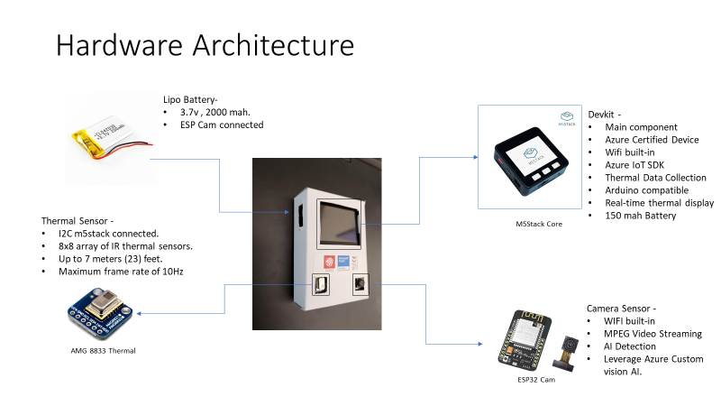

* Main Controller – M5Stack Core –
  + Azure Certified Device
  + Wifi built-in
  + Azure IoT SDK
  + Thermal Data Collection
  + Arduino compatible
  + Real-time thermal display
  + 150 mah Battery
* Sensors –
  + Thermal Camera (AMG 8833) –
    - I2C m5stack connected.
    - 8x8 array of IR thermal sensors.
    - Up to 7 meters (23) feet.
    - Maximum frame rate of 10Hz
  + Camera (ESP 32 Cam)–
    - WIFI built-in
    - MPEG Video Streaming
    - AI Detection
    - Leverage Azure Custom vision AI.
* Battery – Extra 3.7v 2000 mah
* Card Box Layout –

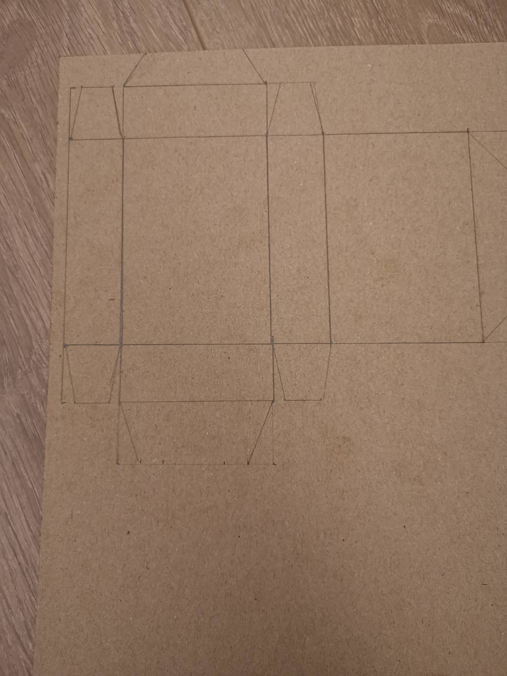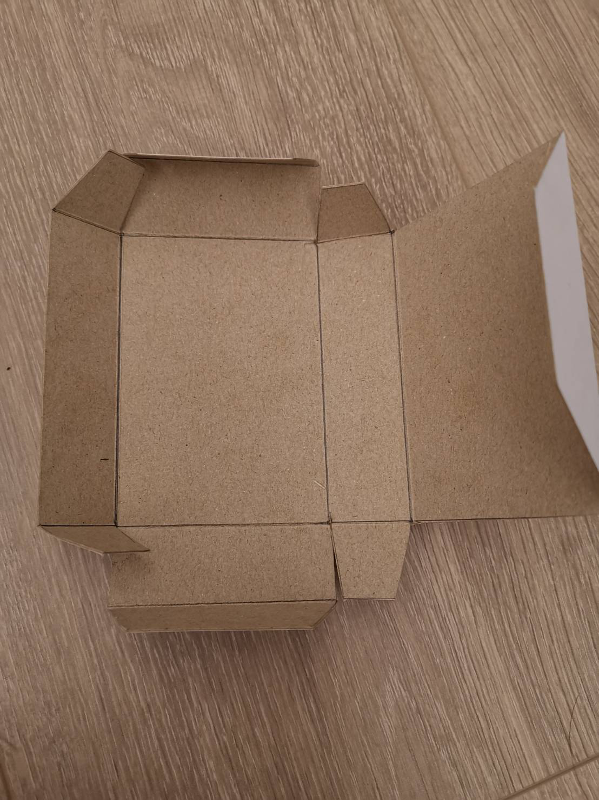

Internal Wired -

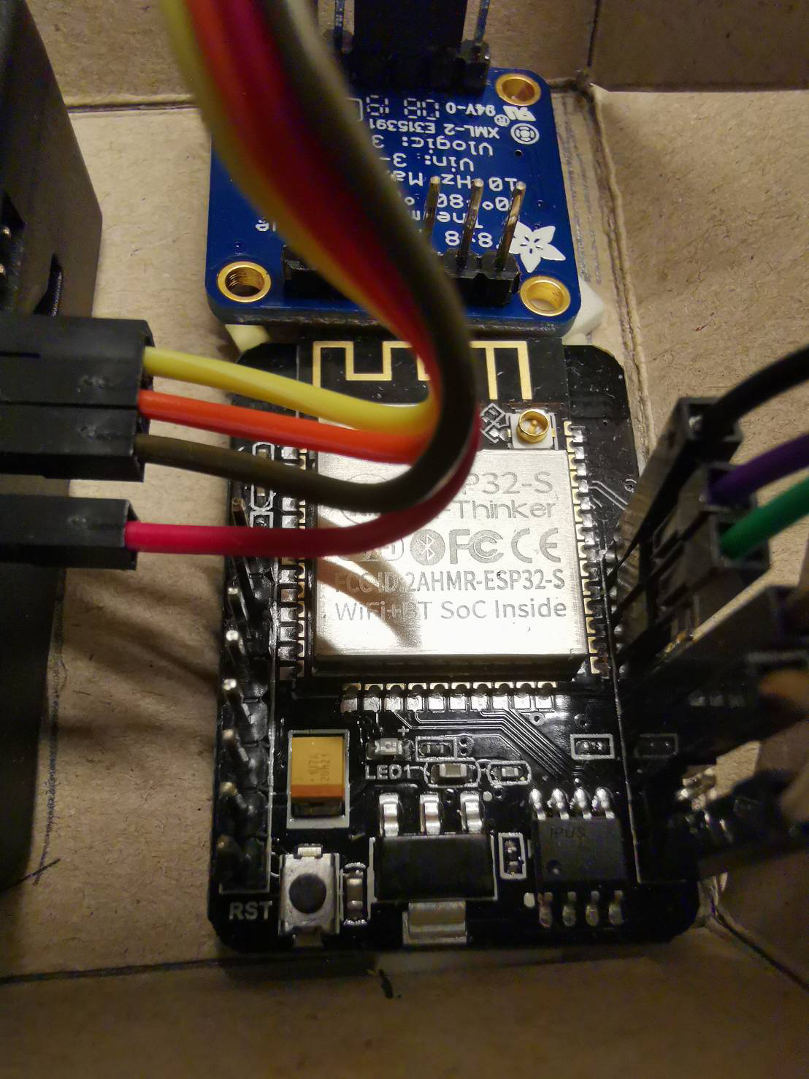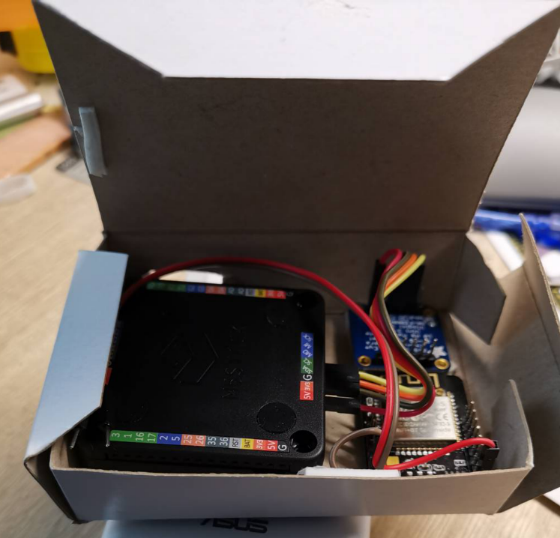

1. AI CARE System Architecture –

**System Overview**

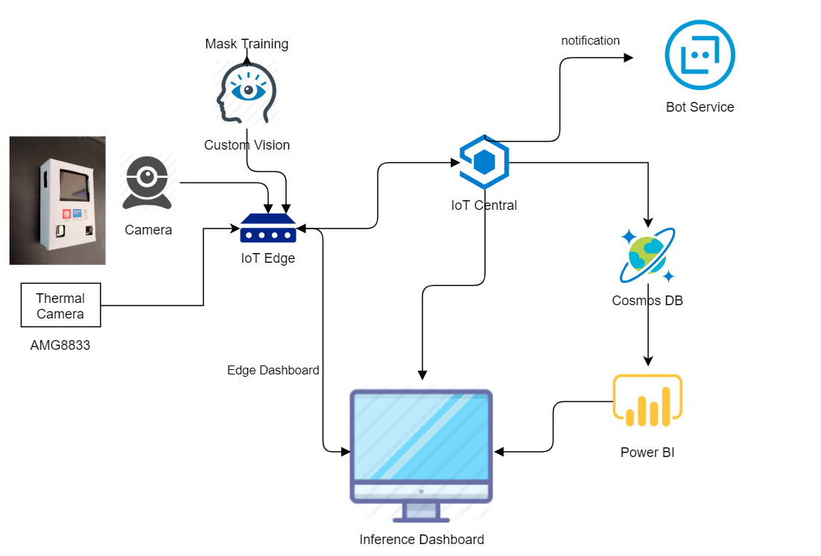

1. Mask Training –
   1. Leverage Azure Custom Vision for mask training in 5 minutes !
   2. Re-train your own dataset to improve your enterprise accuracy.
   3. Deploy AI model as IoT Edge module for quick deployment & distribution.
2. IoT Edge –
   1. AI on Edge for inference performance and data consolidation.
   2. Edge dashboard module for real-time result display.
   3. Large Scale AI Module deployment efficiency.
3. IoT Central –
   1. Overall Coronavirus Epidemic prevention dashboard
   2. Create Your Cross multi-region Summary in 5 mins
   3. Control Sensor device settings and monitoring easily
   4. Notification built-in and quick customization.
4. BoT Service –
   1. Connect to social media notification (Line/Facebook/SMS..etc)
   2. Create your own logic for notification dispatching
5. Power BI + CosmosDB –
   1. Enterprise Dashboard for your deep customization UI requirement.
   2. Develop your enterprise level dashboard based on IoT Central dataset
   3. Quick widgets and drag&drop mode to mash up your complex UI and reporting.
6. Hands-On Guide Tutorial -

* **Device Side** –
  1. M5StackCore –
     1. Development & Pinout Reference – <https://docs.m5stack.com/#/en/quick_start/m5core/m5stack_core_get_started_Arduino_Windows>
     2. Git clone from - <https://github.com/tommywu052/project-AICARE.git>

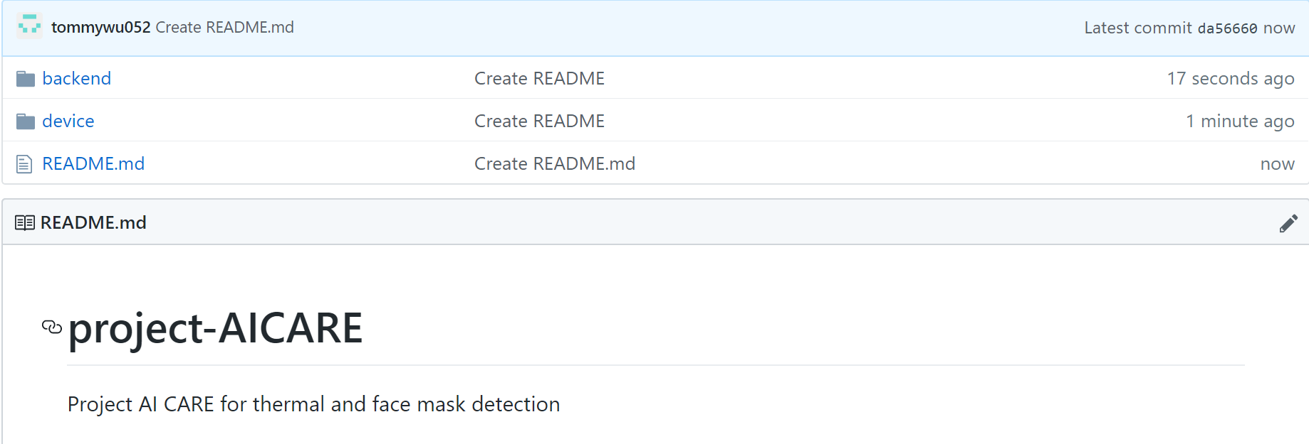

* + 1. Go to [project-AICARE](https://github.com/tommywu052/project-AICARE)/[device](https://github.com/tommywu052/project-AICARE/tree/master/device)/**M5Stack_Thermal**/, modify the code as below for your own wifi ssid / password and Azure IoT Central device connection string.

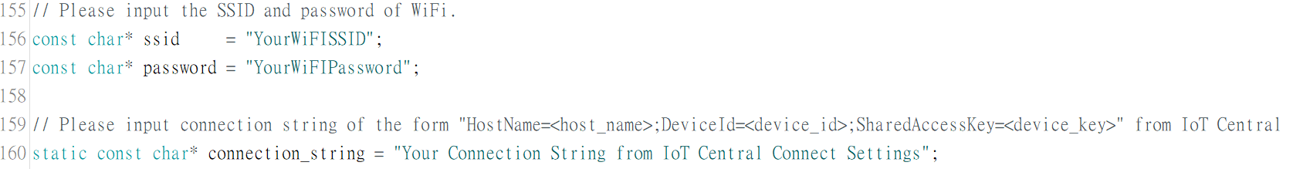

* + 1. Flash the modified .ino file into your m5stack core . make sure you have import the related library as m5stack core reference document as step 1.

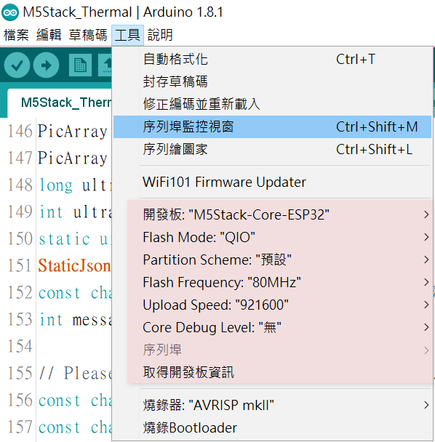

* + 1. Port Connection map

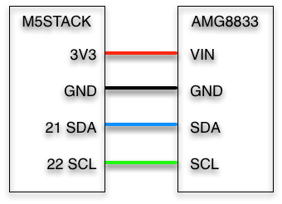

* 1. ESP32 CAM –
* Development & Pinout Reference – <https://www.instructables.com/id/ESP-32-Camera-Streaming-Video-Over-WiFi-Getting-St/>
* ESP32 CAM connect M5stack map –

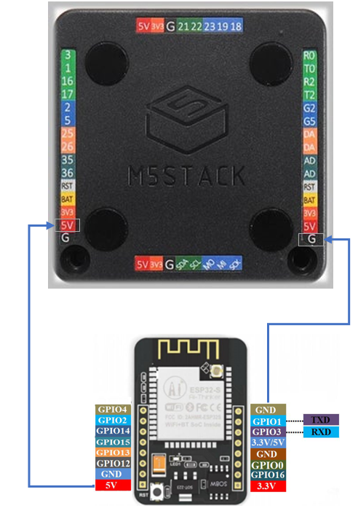

* 1. Battery –
     1. External Battery Pinout map –

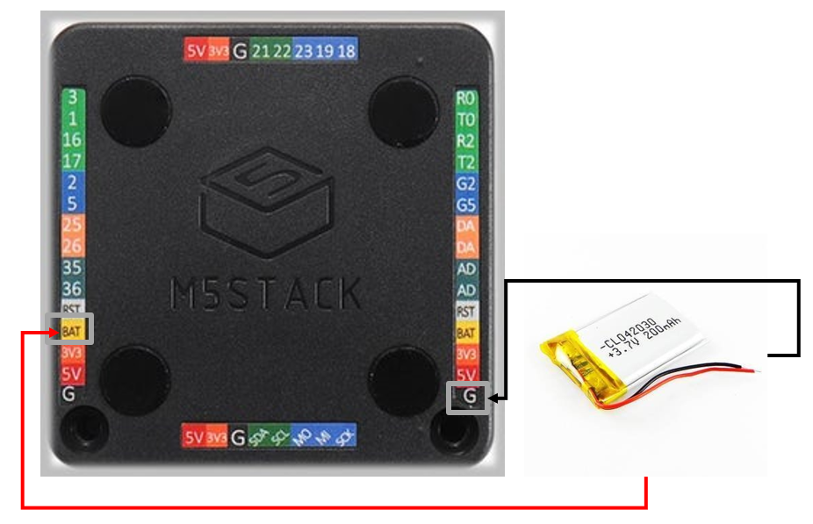

* **Backend Side** –
  1. Mask Training with Azure Custom Vision –

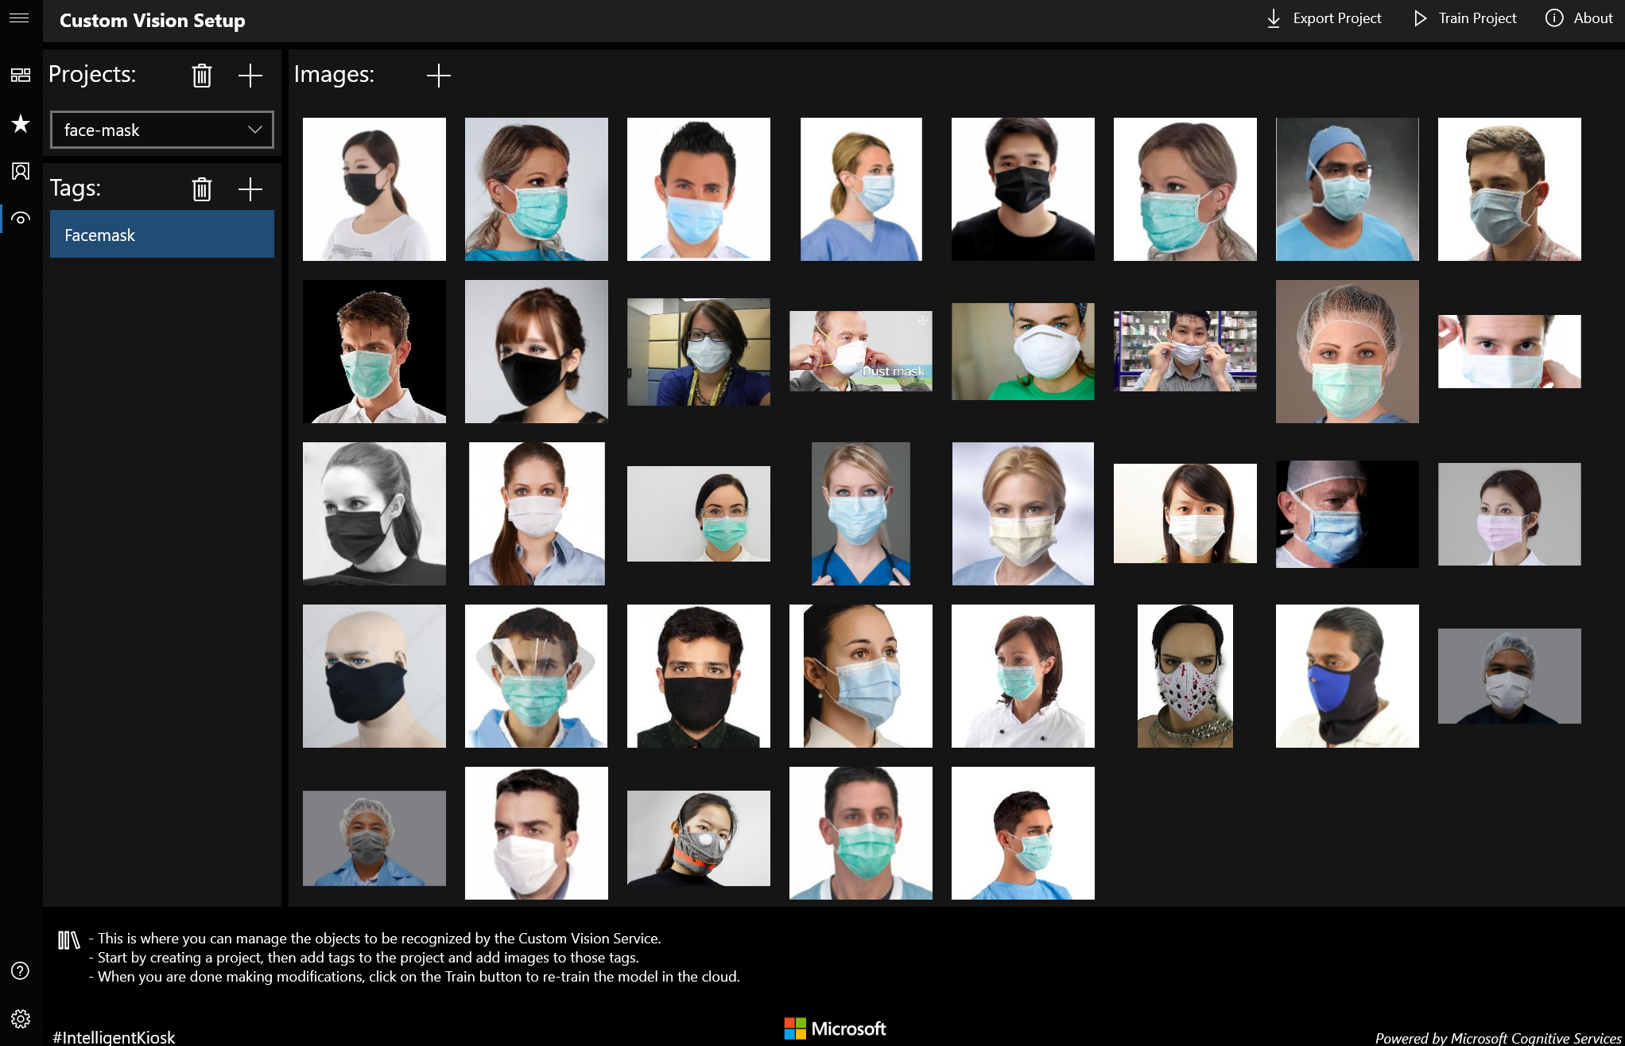

* + 1. Download Kiosk App : <http://aka.ms/kioskapp>
    2. Setting your training & prediction key in kiosk app from <https://www.customvision.ai/> website.

In Custom Vision Website Keys -

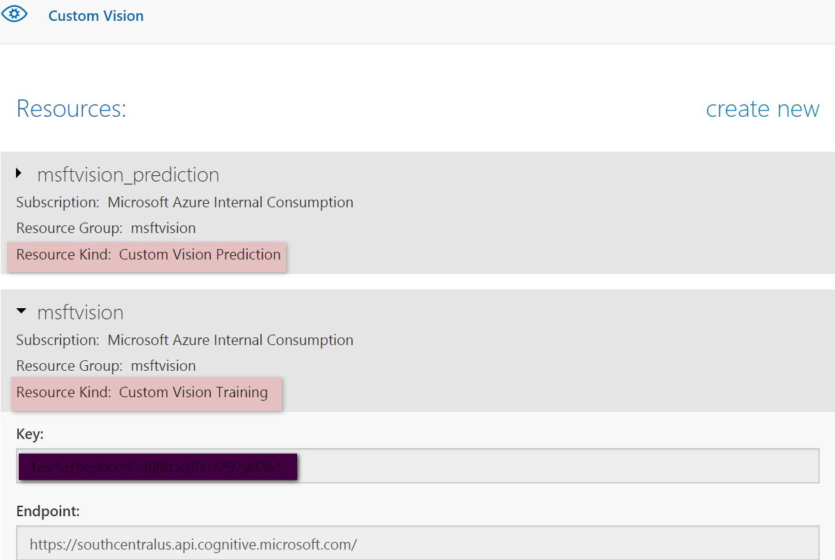

In Kiosk App Settings –

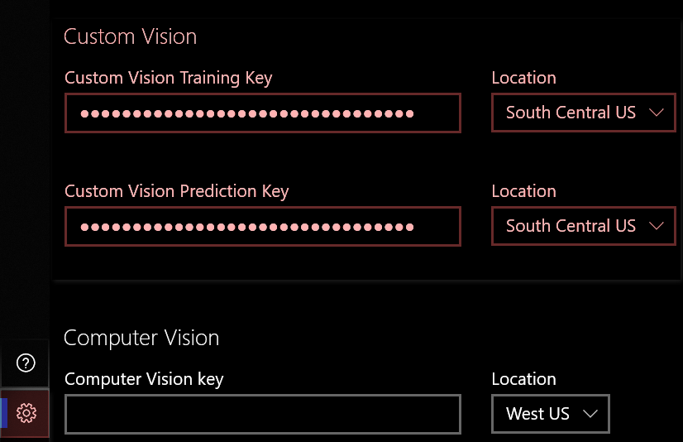

* + 1. Mask Training Steps with Custom Vision AI –
  + Leverage Azure Custom Vision for mask training in 5 minutes !
  + Add Common Images by Bing Search Engine.
  + Add Your own mask training images with camera or local images to improve accuracy.
  + One-click training and export AI model for real-time testing
  + Deploy as IoT Edge module for scale deployment.
  1. Edge Computing with Azure IoT Edge -
* Web service over HTTP running locally that takes in images and classifies them based on a custom model built via the Custom Vision
* Can be deployed and configured via Cloud
* Can leverage Edge device like GPU/VPU/FPGA to improve the inference
* Adapt to different acceleration framework like OpenVINO, CUDA , DeepStream, ONNXRT and etc.

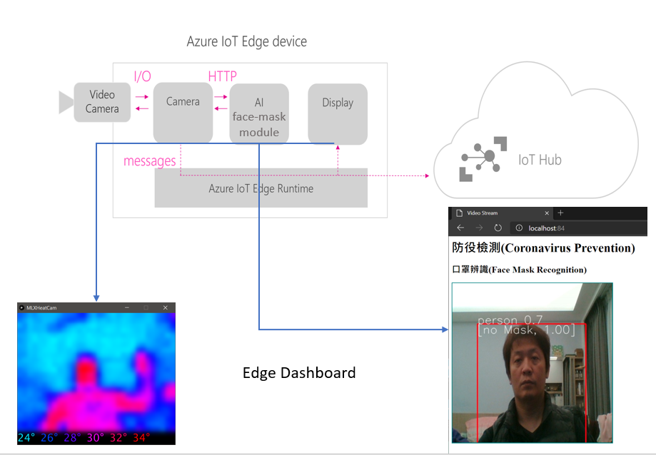

* + 1. Refer the document <https://github.com/Azure-Samples/Custom-vision-service-iot-edge-raspberry-pi/tree/master/> for IoT Edge setup, remember to choose amd64 for x64 platform.
    2. Install the node-red IoT Edge module as - <https://github.com/iotblackbelt/noderededgemodule>
    3. Import the code from <https://github.com/tommywu052/project-AICARE/blob/master/backend/IoTEdge/AICare-nodered-flows.json> into your node-red edge.

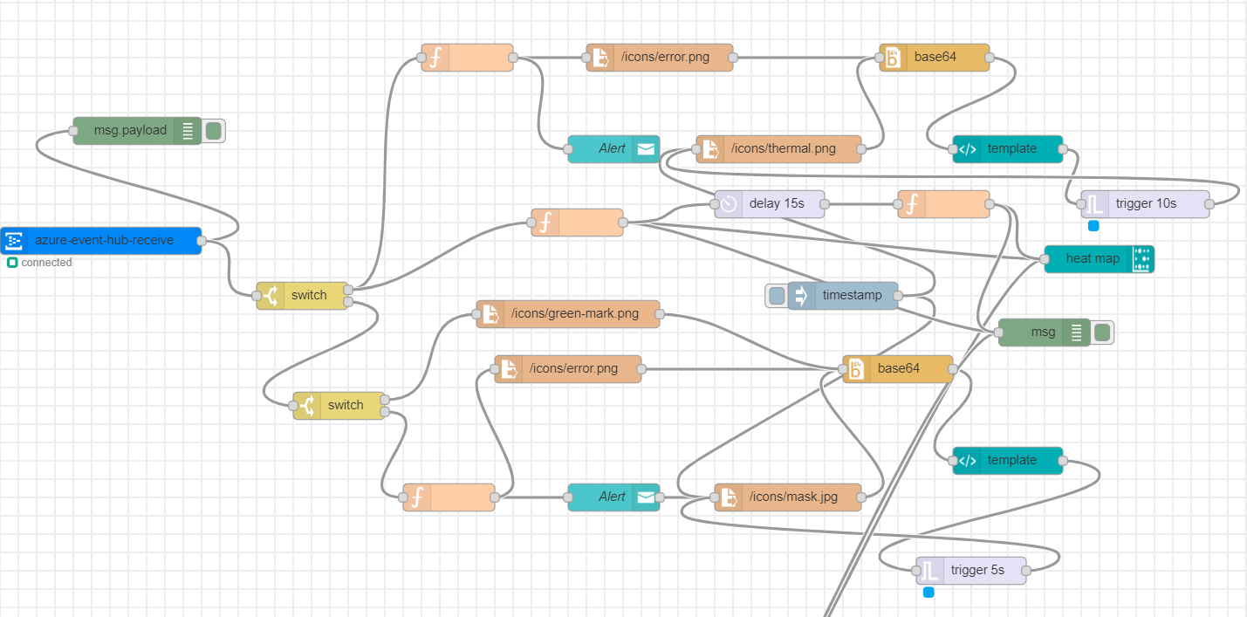

Review Your UI widget as <http://localhost:yourport/ui>

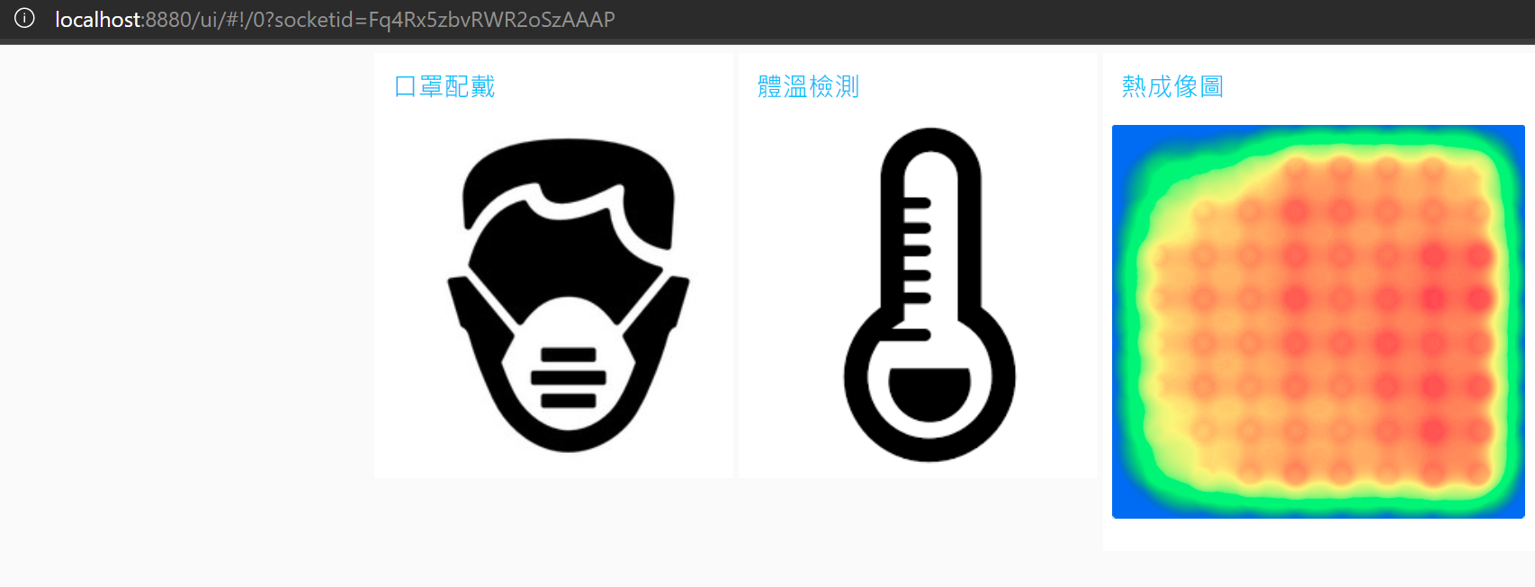

* + 1. Export Custom vision model as IoT Edge and copy **model.pb** and **labels.txt** from the zip file into docker images via docker cp.

docker images

REPOSITORY TAG IMAGE ID CREATED SIZE

a9publicregistry.azurecr.io/imageclassification 0.3.8-maskai 0be0b6d56941 2 days ago 1.57GB

docker cp model.pb 0be0b6d56941:/app/model/model.pb

docker cp labels.txt 0be0b6d56941:/app/model/labels.txt

* + 1. Get the inference code from - <https://github.com/tommywu052/project-AICARE/blob/master/backend/IoTEdge/yolocv-public.py>

Modify the code - line 22-24 as your device key on IoT Central :

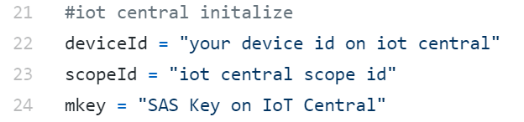

Modify the code – line 63 as your image inference host at 5.5.1 step



Modify the code – line 261 as your ESP32 CAM streaming IP (ex:192.168.43.138, port 81 is default MJPEG streaming )



* 1. Power BI Dashboard -
* In few clicks, you can set up an end-to-end solution that pulls exported Edge measurements, devices, and device templates data from IoT Central
* Power BI Solution for creates the data pipeline in your IoT Central that brings data from your Azure Event Hub

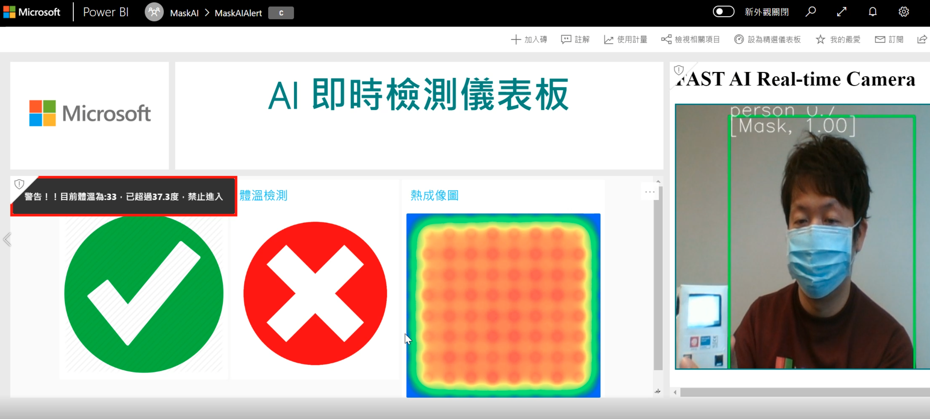

* + 1. Refer the document for Real-Time Streaming – <https://docs.microsoft.com/zh-tw/power-bi/service-real-time-streaming>
    2. Add Real-Time widget with Web Content and Streaming data set -

<https://docs.microsoft.com/zh-tw/power-bi/service-dashboard-add-widget>

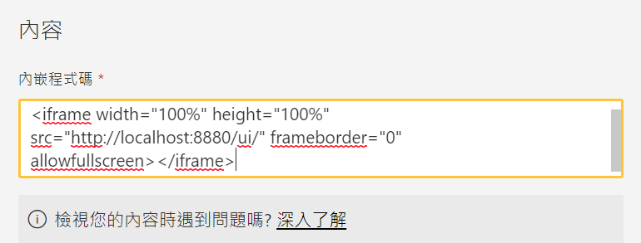

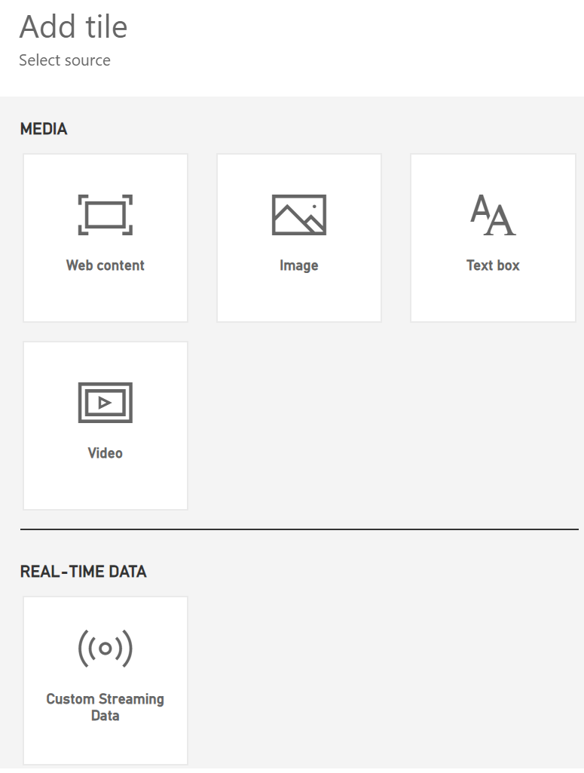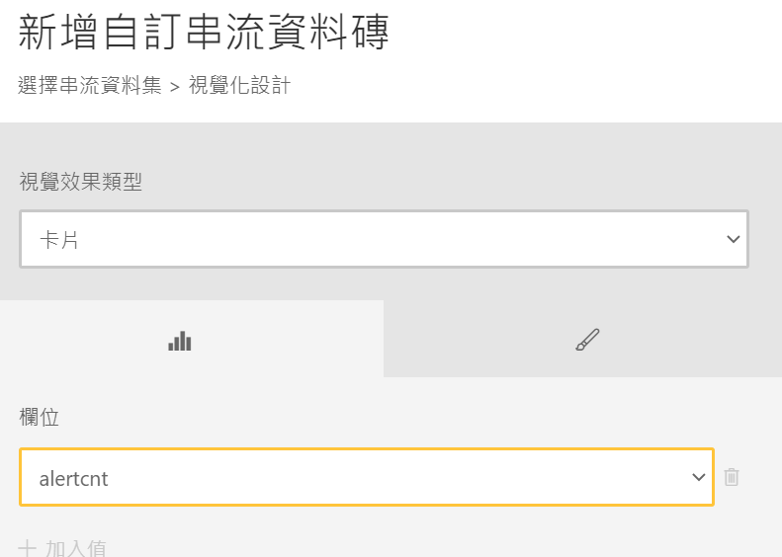

* + 1. Note – Data on real-time dashboard is coming from IoT Central export as Azure Event Hubs-

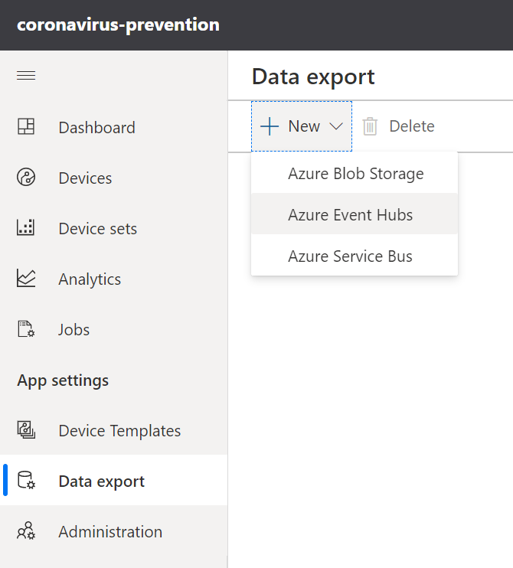

* 1. IoT Device Control and Monitoring on IoT Central -
* Summary Dashboard - Data from Thermal/Camera Sensors and Alert Notification Triggered
* Device Control & Monitoring through command/settings pages

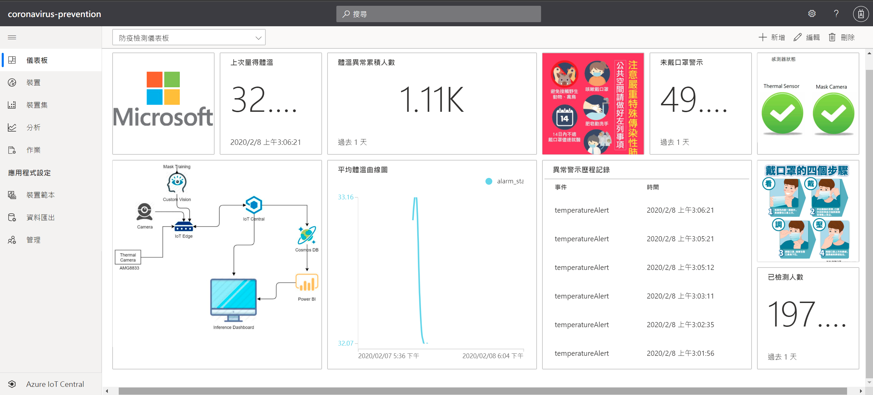

* + 1. Refer the document to Create Your IoT Central Dashboard Application - <https://docs.microsoft.com/zh-tw/azure/iot-central/core/quick-deploy-iot-central>
    2. Device Configuration –

Configure your device telemetry/settings/command/triggers on the device template (mapping the code on the device side Arduino and python code)

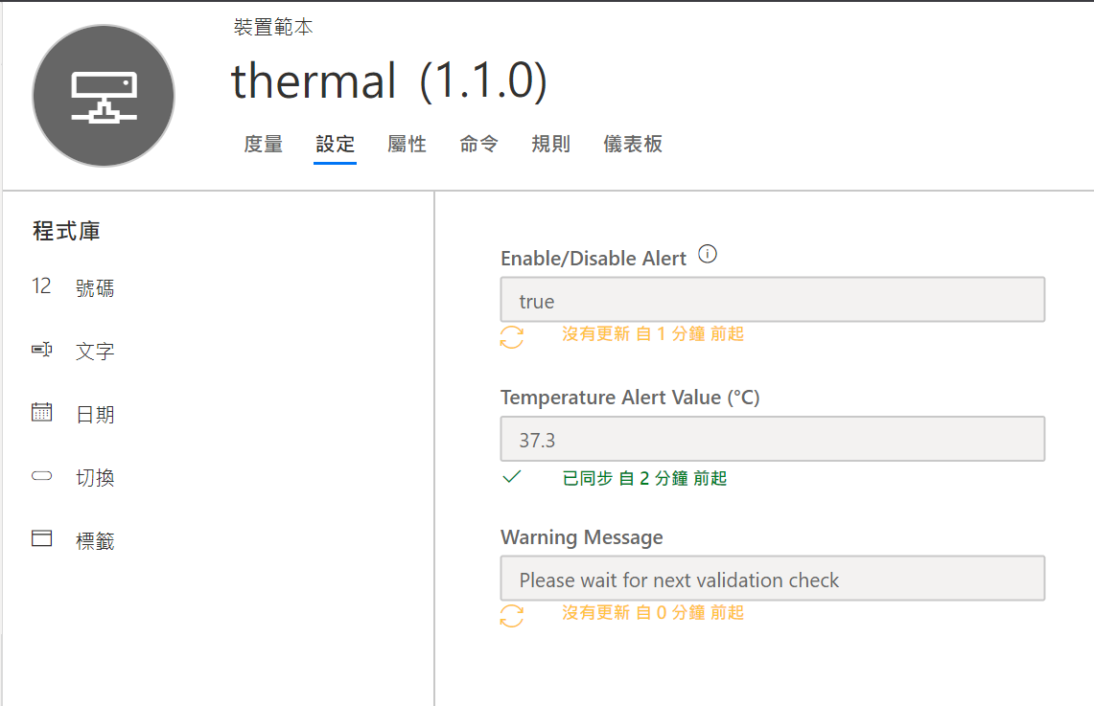

* + 1. Enable Alert Notification –

<https://docs.microsoft.com/zh-tw/azure/iot-central/core/quick-configure-rules>

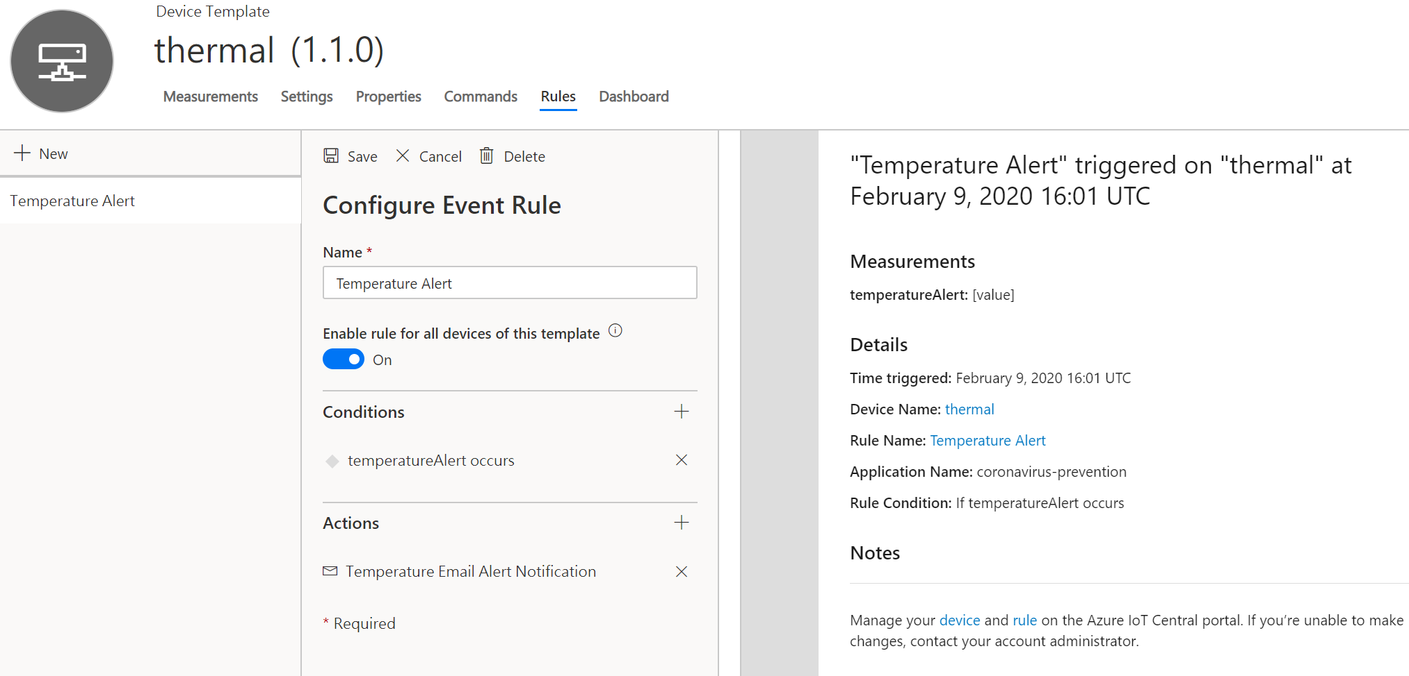

* + 1. If you just want to copy my existing application template quickly , Please create your application based my share template, click the below - <https://apps.azureiotcentral.com/build/new/7490af0a-4e9c-4b54-b7a6-bd0c6092e522>
  1. (To-Do) Azure BOT service integration –
* Real-time notification for multiple social media channels (LINE/FB/..).
* Integrate speech service for interactive notification.
* No-Code for channels integration.
* Flexible and Extensible

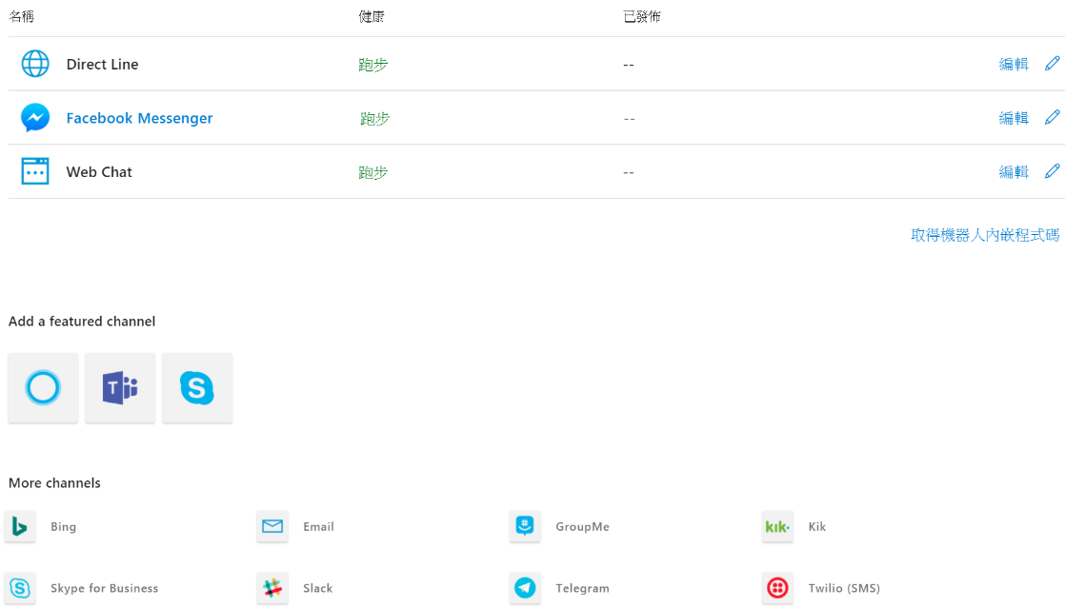

Check this for more detail notification - <https://docs.microsoft.com/zh-tw/azure/bot-service/bot-builder-tutorial-basic-deploy?view=azure-bot-service-4.0&tabs=csharp>

LINE Integration - <https://docs.microsoft.com/zh-tw/azure/bot-service/bot-service-channel-connect-line?view=azure-bot-service-4.0>

1. Demo Video Reference –
   1. AI Care Edge Demo - <https://youtu.be/Wh_21go4Thg>
   2. AI Care Device hands-on - <https://youtu.be/d4HqonLCNmM>
   3. Mask Training by Custom Vision - <https://youtu.be/eEb9vfvgW0g>
   4. Mask Inference Demo with Custom Vision on IoT Edge -<https://youtu.be/dXDriffeE6Q>
2. Feedback -

Welcome and Improve the code based on your advanced requirement .Please contact [towu@microsoft.com](mailto:towu@microsoft.com) or submit request on the github. Thanks !